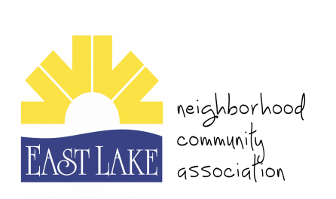
East Lake Neighborhood Community Association
East Lake Community Scholarship 2023

Purpose: To provide a one-time college scholarship to two (2) eligible seniors currently residing in the East Lake Community.

Award: Two (2) total non-renewable scholarships of $500 each will be awarded to two (2) separate individuals selected by a committee of East Lake residents to be used towards any post-secondary learning opportunity.

Eligibility:

- Applicant must be a resident of the East Lake Community.
- Applicant must have at least a 3.0 GPA (unweighted).
- Applicant must demonstrate involvement within the school and community.
- Applicant must be graduating from high school in spring/summer of 2023.
- Applicant must show proof of enrollment from the post-secondary institution they intend to enroll at in Fall 2023.
- Applicant must submit ALL completed materials by the deadline (Friday, May 26th, 2023).

Application: Please submit the following documents in a sealed envelope.
- Scholarship application
- Scholarship essay
- Two (2) letters of recommendation
- High School transcript
- Proof of enrollment to the institution being attended

ENTRY REQUIREMENTS: Essays and recommendation letters must be typed, double-spaced, in 12-point Times New Roman or an equivalent font, with numbered pages and one-inch margins.

ESSAY CRITERIA:
In 500-700 words, write an essay responding to the following topic: Describe how your family and the community in which you grew up have impacted your desire and motivation to obtain a college degree. Additionally, be sure to include what you intend to accomplish with your degree and how you will give back to your community.

Please submit the completed application and materials in a sealed envelope to:

ELNCA
Attn: Scholarship Committee
P.O. Box 170125
Atlanta, GA 30317

Applications should be postmarked by no later than Friday, May 26th, 2023. (Late applications will not be considered.)

Any questions may be sent to Jeff Philliber at jeffphilliber14@gmail.com.

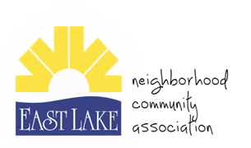
East Lake Neighborhood Community Association
ELNCA Scholarship Application 2023

All sections of this application must be completed.
Student First Name:  Student Last Name: |  | Parent First Name:  Parent Last Name:
Grade: __________  High School: ________________________ |  | Male: _____ Female: _____
Class Rank: _____/_____

GPA: Weighted _________ Unweighted: _________

Counselor Signature: ____________________________

Mailing Address:

Street: _________________________________________________________

City: State: ZIP:
Daytime Telephone Number: ( )
Email Address:
Date of Birth: Month Day Year

Name of post-secondary school

attending in the Fall of 2023:

CLUBS AND ACTIVITIES

Club/Activity Name | Year(s) involved (Fr., Soph., Jr., Sr.)

A. The following items must be attached to this application form in order to establish your eligibility and to be reviewed by the scholarship committee.

B. Circle “YES” or “NO” to confirm you have attached each item as required.
YES | NO | Scholarship Application Form completed in its entirety  (incomplete applications will not be considered)
YES | NO | Two (2) Letters of Recommendation. Letters should be written and signed by persons with significant knowledge of applicant’s academic or extra-curricular achievements.
YES | NO | Completed and Typed Essay
YES | NO | High School Transcript
YES | NO | Proof of enrollment to a post-secondary institution in the Fall of 2022.

STATEMENT OF ACCURACY

I hereby affirm that all the above stated information provided by me is true and correct to the best of my knowledge.

I hereby understand that if I am chosen as a scholarship winner the money would be used to cover my expenses related to attending the post-secondary school of my choice.

Signature of scholarship applicant’s parent: _________________________ Date: _________________

Signature of scholarship applicant: _________________________ Date: _________________

